# CS 340 README Template

**Student**: Raphael Rose

**Date**: Dec 2, 2020

**Assignment**: 7-1 Project Two

**Course**: CS-340-X2139 Client/Server Development

## About the Project/Project Title

The purpose of project two is to create a dashboard that allows a user (specifically Grazio Salvare) to identify and navigate the pets available for adoption in the Austin, TX area.

The dashboard has 3 key features:

1. A data table providing all the information for the pets
2. A pie chart identifying the breed of pets in the table
3. A map showing the location of the pet

In addition it uses a radio button as a filter to quickly identify the pet types that meet the Grazio Salvare requirements for service animals.

## Motivation

The motivation of this project is to streamline the efforts of querying a database and providing available information directly to the customer.

## Getting Started

Setup is broken into three sections:

1. Setting up the mongodb session and loading data
2. Installation of the appropriate files
3. Running the dashboard

**Section 1: setting up mongoDB**

For this exercise you will need python installed with pymongo. I am using pymongo version 3.10.1 but any version of after 3.9 will be sufficient.

The first step of this process is to import the AAC data needed to MongoDB. To do so follow the guide provided:

To setup your mongoDB session complete the following:

1. Open a terminal window
2. #start mongo with authentication

/usr/local/bin/mongod_ctl start

1. #To load the data sets into this new MongoDB server environment, execute the following commands:

cd /usr/local/datasets

/usr/local/bin/mongod_ctl start-noauth

#**** copy the port number given in the output, example *****

#**** be sure to replace the ##### with the port number you were given

mongoimport --port ##### --db city --collection inspections ./city_inspections.json

1. mongoimport --port ##### --db AAC --collection animals --type=csv --headerline ./aac_shelter_outcomes.csv
2. Enable authentication
3. # now stop mongo

/usr/local/bin/mongod_ctl stop

# and start mongo with authentication, again make note of the

/usr/local/bin/mongod_ctl start

or the screenshots below

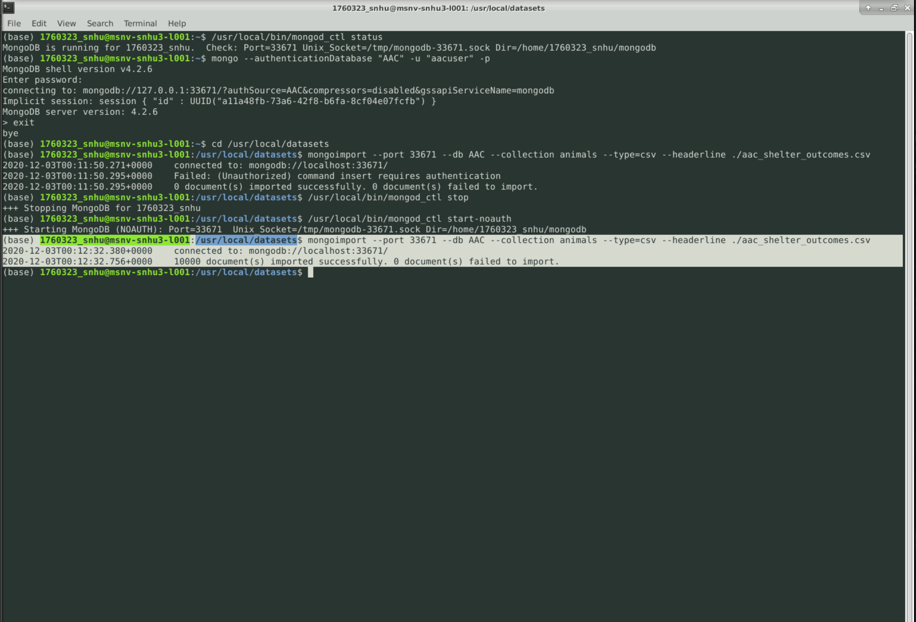

The next step is to setup Admin and User privileges detailed in the below screenshots:

**1. Admin**

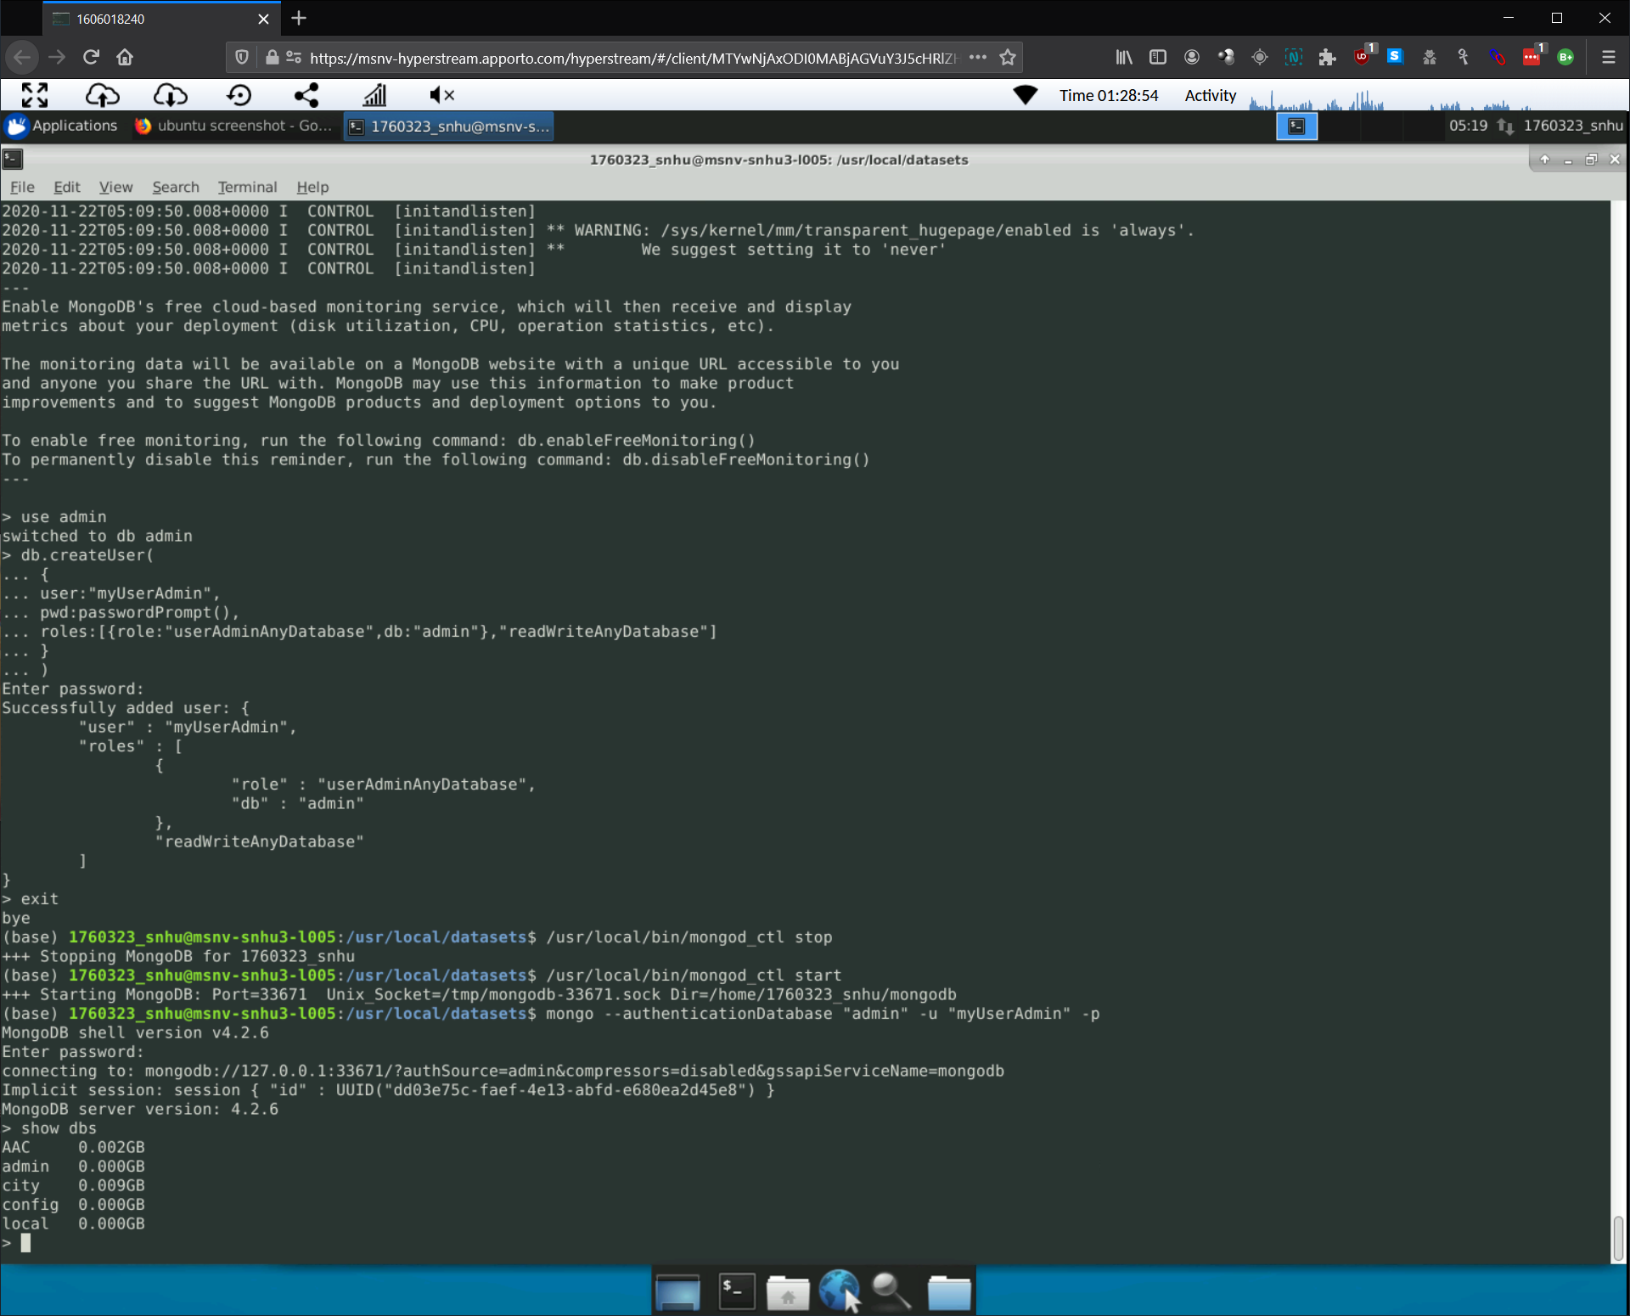

**2. aacuser**

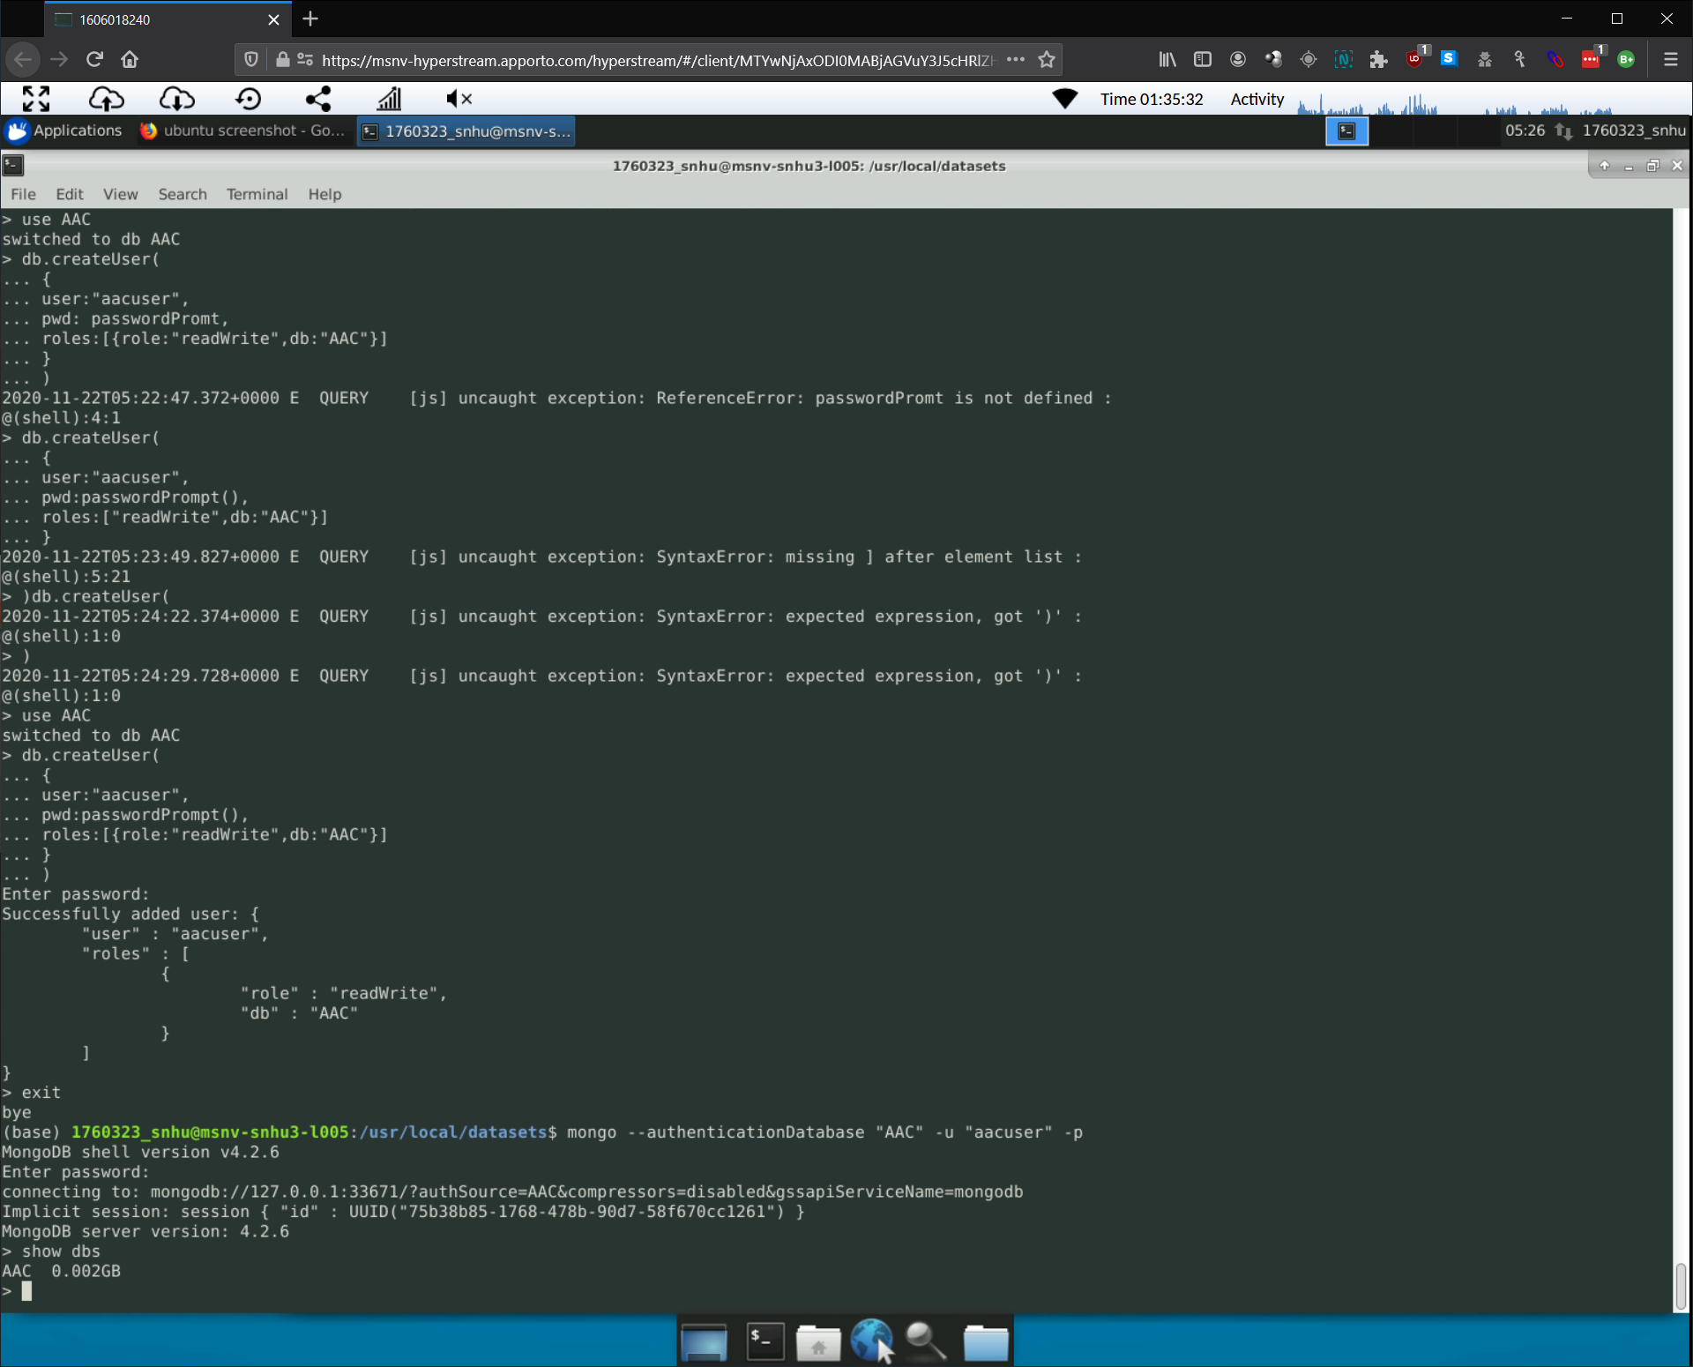

To get a local copy up and running follow these instructions:

Step 1: place the file MongoDBCRUD.py in your home directory

Step 2: open the CRUD.ipynb in a jupyter notebook environment

## Section 2: Installing

To install download the following to your home directory:

MongoDBCRUD.py

ProjectTwoDashboard.ipynb

**Section 3: Usage**

1.To use select the appropriate radio button at the top

2.To update the map select a radio button next to a row you want to display

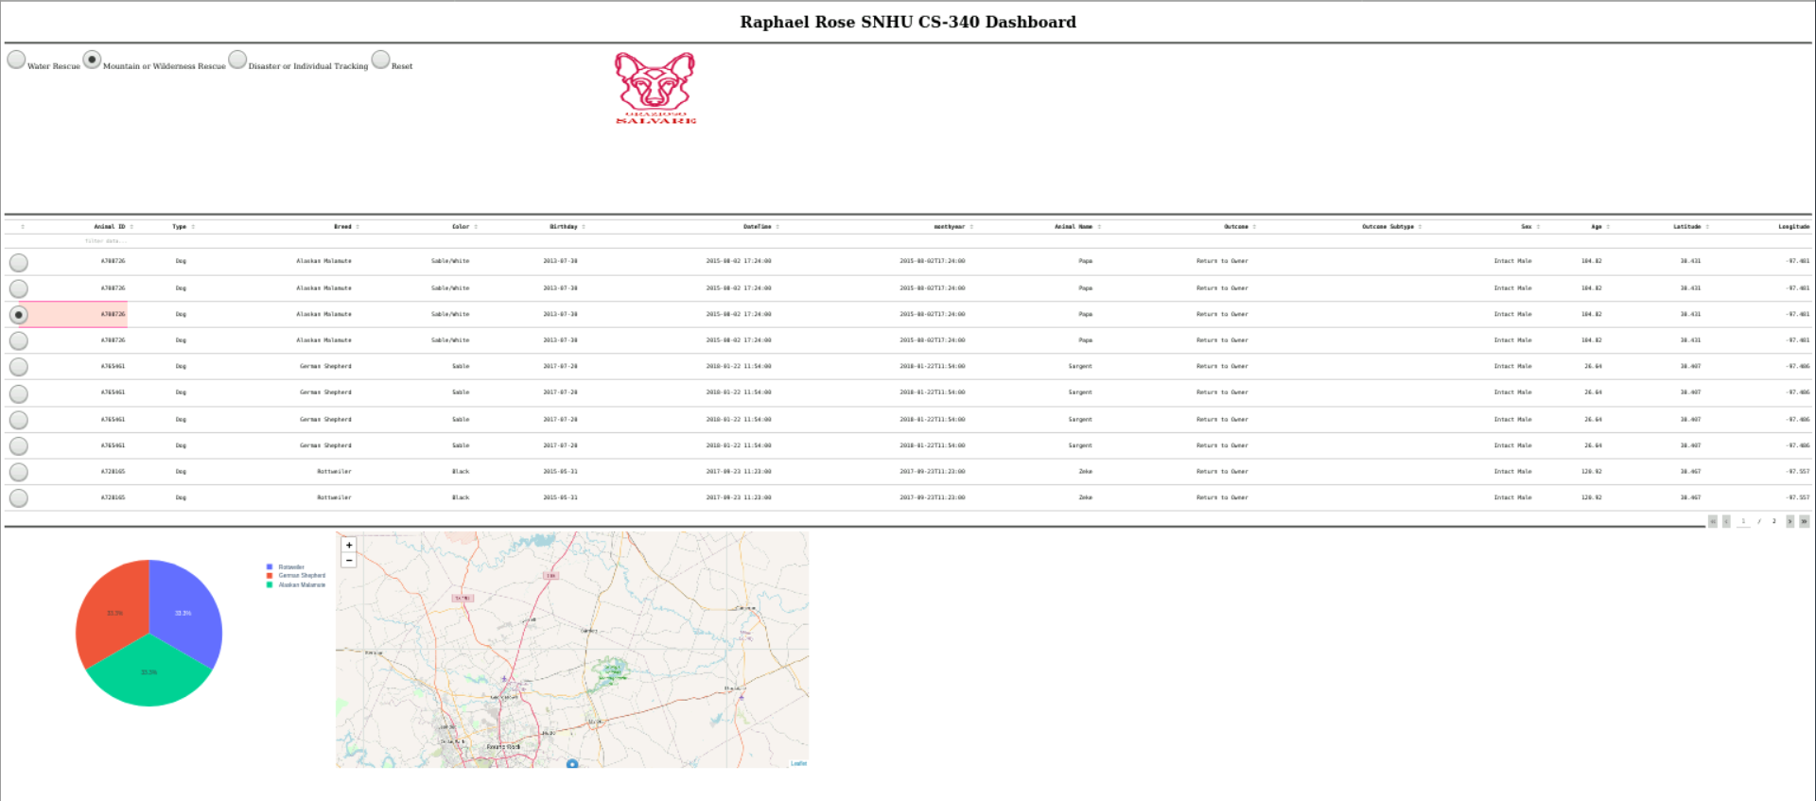

### Code Example

**Map**

Shows the location of the selected row

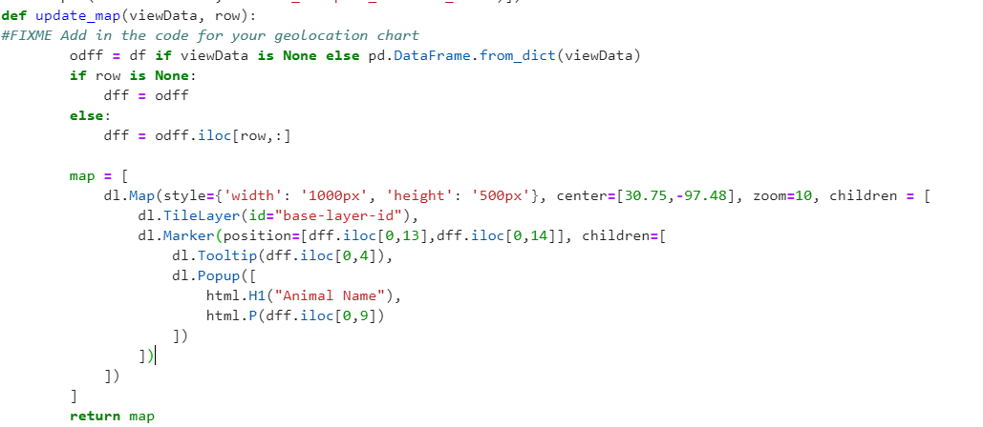

**Graph**

Shows all data in a pie chart broken out by breed, not limited to what is explicitly shown in the table

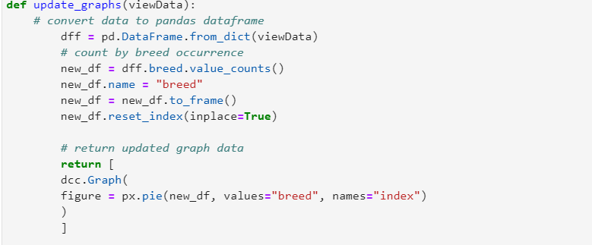

**Table**

Shows all queried values

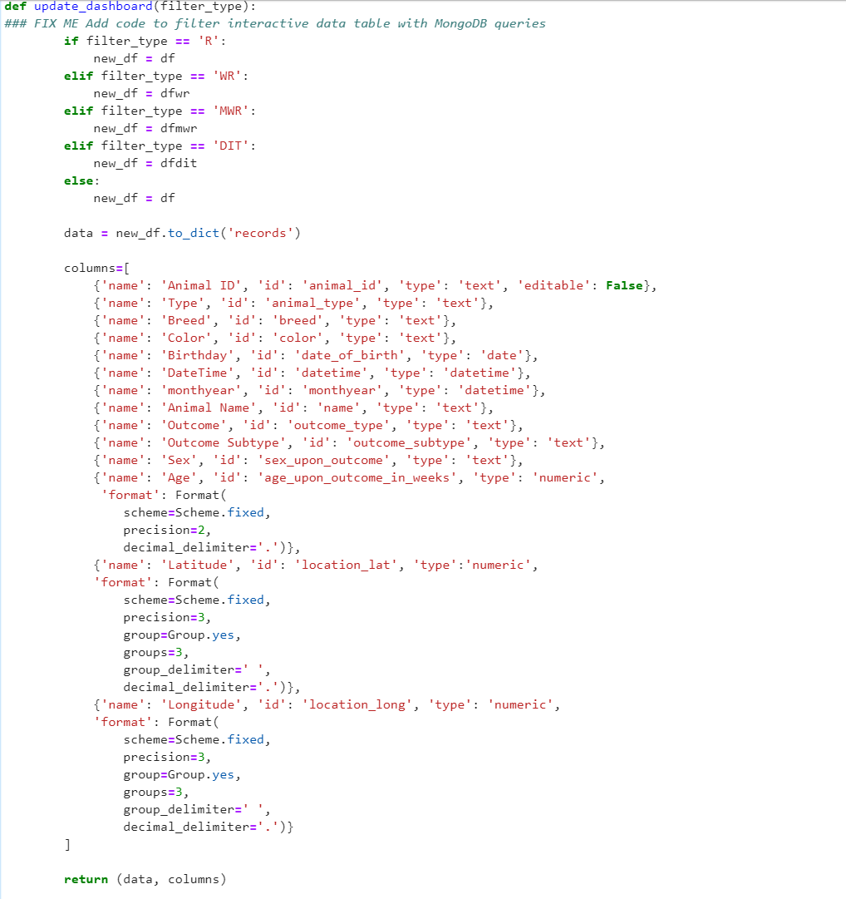

**Radio Button**

Defaults to reset and toggles between options

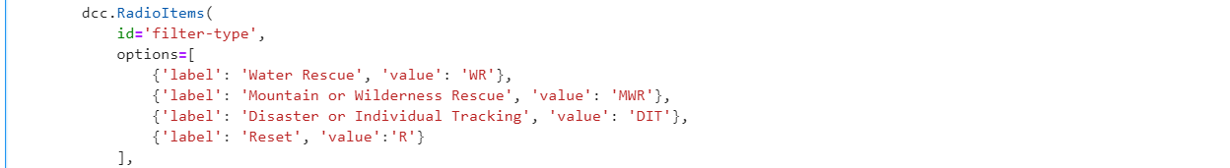

## Contact

Your name: Raphael.Rose@snhu.edu